The hunger games campout!!!!

Friday
7:30PM - Get there and set up only tents in the "districts" campsite

9:00PM - Cracker Barrel

9:30PM - TLC

10:30PM - lights out

Saturday
7:00AM - wake up

7:30AM - breakfast - scrambled eggs, biscuits and gravy, milk and juice, and bacon

8:30AM - flag / reaping ceremony - this is were the contestants name's will be drawn

9:00AM - hunger games training - 30 minute sessions, not in order

Fire building
Learn how to build a shelter
First aid
Orienteering speed race
Target practice... With nerf guns
Knot tying

12:00PM - lunch / tribute parade - sloppy joes, chips, cookies

1:00PM - Caesar Flickermen's show

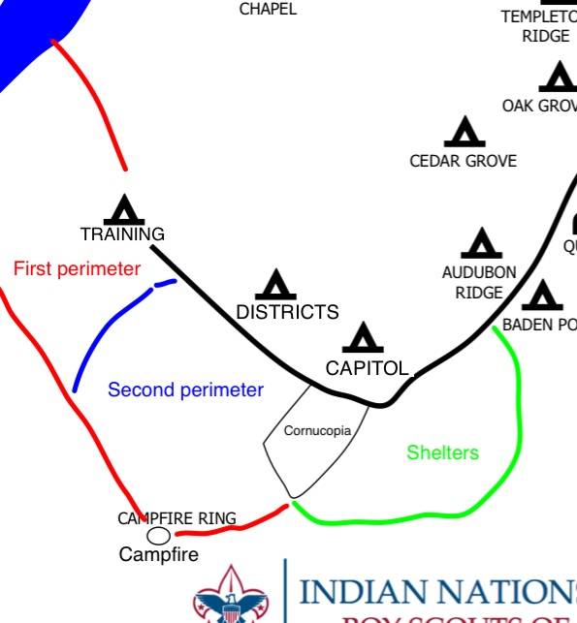
1:30PM - THE HUNGER GAMES!!! - while other patrols members build shelters and complete advancement, ask adults to sponsor their kid, or they can simply cheer for there district tribute!

4:00PM - hunger games show down - everyone gets together in the cornucopia to watch the finale of the games

4:30PM - closing flag / winners crowning

Camp Darby

5:00PM - dinner - fettuccine Alfredo

6:00PM - dessert - iron chief style with a hunger game's twist

7:00PM - Monizuma spoon

8:00PM - campfire

9:30PM - night game - hunger games again but this time everyone who wants to play can play

11:00PM - lights out - everyone goes to sleep in there shelters

Sunday
7:00AM - wake up

7:45AM - breakfast - pancake, sausage, milk and juice

9:00AM - chapel

10:00AM - leave camp (hopefully)

Patrol leaders checklist

[ ] have your battle flags ready

[ ] CALL your members and asked them to come

[ ] get your members ready for training?

[ ] set up costumes?

[ ] inform your members of the 25$ camping fee

[ ] explain to your members the agenda

[ ] go over game strategies?

The main thing is call your members and let them know about this campout! I can't do this without you guys and its up to you to let them know why they should come to this event. (And believe me they don't want miss out on this!)

Some other information you should know

Each of the Stickmen will be dressed as a different character from the hunger games, Tyler will be Eiffie Trinket, david will be Caesar Flickermen, nick will be Haymich, and Eric will be that gamekeeper guy with the funny beard.

The 4 people rule will still apply to this campout, you need to have AT LEAST 4 members of your patrol present to not have to merge with another patrol

Each patrol has a specialty that give them a different advantage during the event
2- masonry - Ravens - One free tent for using with shelter
3- technology - piranhas - Two walkie talkies to use during the games
4- fishing - Phoenix - Shrimp to add for dinner
5- power - black nights - Lantern for your shelter
6- transportation - Eskimos - A water bucket during the games that they can move around
7- lumber - flaming arrows - Plywood for building shelter
8- textiles - roadkill - Extra tarp for building shelter
9- grain - crusaders - French bread to go with dinner
10- livestock - Vikings - Chicken available for dinner
Sponsored items

-ponchos - 1,500$
-shield - 1,000$
-extra shirt - 1,700$
-extra flag - 2,000$
-water guns - 2,500$
-twinkies - 300$
-duck tape - 500$
-marker on a stick - 700$
-Backpack - 1,000$
11- agriculture - Tbirds - extra garlic/parsley for dinner

Rules for the games
no running or punching or kicking or shoving or throwing,
you need to be "slashed" with a marker in the chest or back to die,
after the first hour all contentions must move to a second marked perimeter, after the second hour all contestants must move into the cornucopia field,
staff members will be wearing a red "X" on there chest don't mess with them,
do not carry water buckets or move them,
BE HONEST!! Don't pretend you didn't get shot or slashed,
when you get out, go help you patrol with what ever they have decided to do.

